Hosting a Website on Google Cloud Platform (GCP)

1. Introduction
This document provides a full step-by-step guide to host a production website on Google Cloud Platform (GCP).
It covers:
- VM creation
- SSH access (PuTTY)
- File upload (WinSCP)
- Web server + database setup
- Deploying the application
- Configuring NGINX reverse proxy
- Running your app as a system service
- Accessing the site from domain/IP
2. Create a VM Instance in Google Cloud

Steps:
- Go to Google Cloud Console → Compute Engine → VM Instances
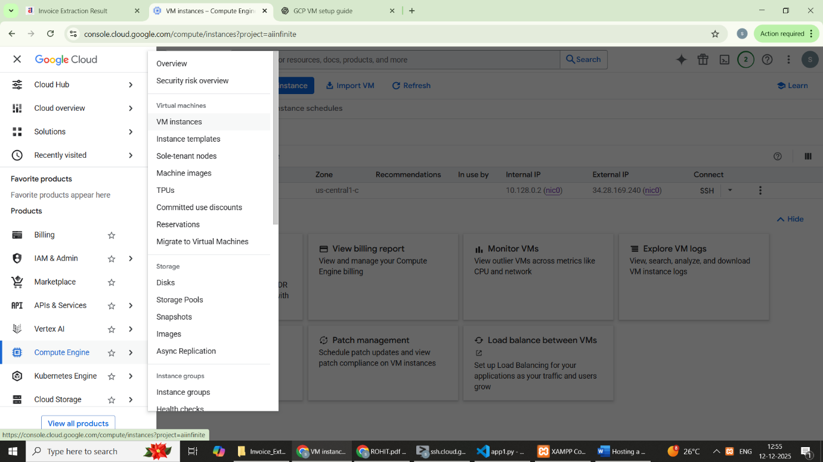
- Click Create Instance

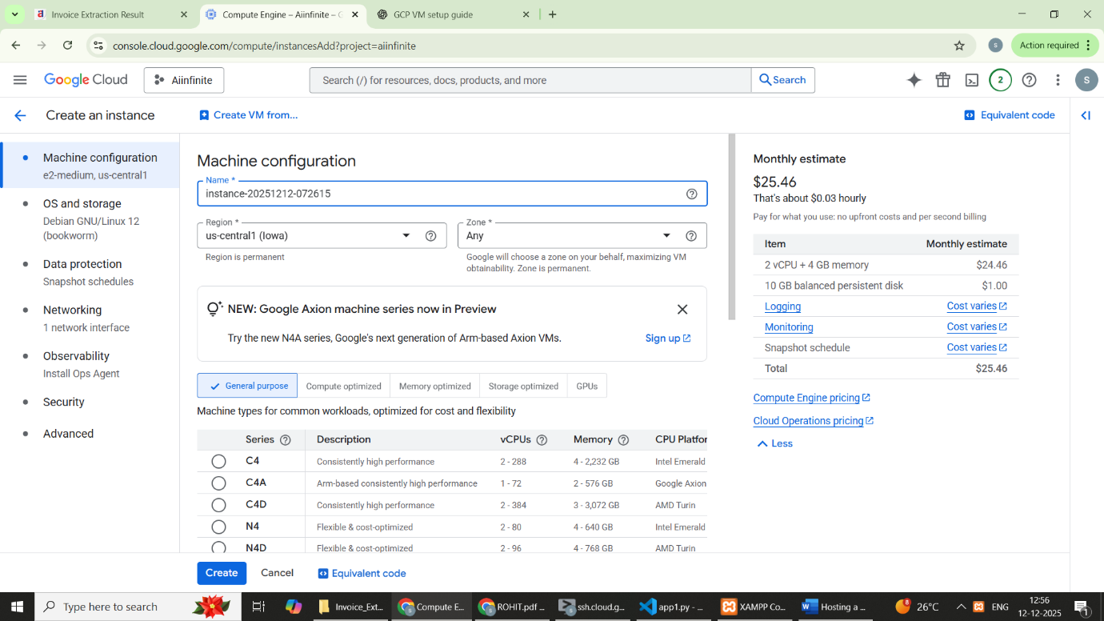
Create Instance and Save:

